React Js
- What is Reactjs?
- React js is a javascript librardriy, it was developed and maintained by facebook. Mainly using the reactjs we can develop the faster web applications compare to other technologies.

- What is Dom?

- Dom Means document object model(DOM)
It is a child object to the window, it is used to add dynamic content to the html pages, and also to add dynamic validations.
When html document is loaded in the browser it becomes a document object.

- What is Real DOM?
- Real dom is also called as a physical dom.
- It will work at the browser level.
- Every time it will create a memory instance.
- It will reload entire web application at a time.
- So consume more memory space but gives poor performance

- What is Virtual DOM?
- Virtual DOM is a logical dom
- It will work at the react application level it self so it will occupy entire memory space.
- It will check the previous state with new state in the component tree structure
- If any modifications are there then only it will reload only updated component or state
- So it will consume less memory but it will improve high performance.

Diffing alrogihem

- What is react features?
React features are
- Jsx(Javascript xml)
- Components
- One-way-data binding
- Virtual dom
- Simplycity
- Performance

6.What is jsx?
- Jsx is an javascript xml, it is an extention to the javascript
- Jsx is nothing but a combination of javascript, Custom tags, xml.
Advantages of jsx
It will combine 3 codes,
Javascript, Customtags , xml tages.
It will make the react application more eligent and simple
It is a faster than regular javascript
It makes easier to create templates.
Browser con’t read to the jsx
Bable translate jsx to html or js .

- what is component?
A :- Component is a piece of code or fundamental building block of a React application.
Every React application contains at least one root component and n- no of child components.
All components will form like as Tree structure in the browser at the time of running a React application.
Every React component can have their own structure methods as well as API’s
There are two types of Components:-
a. Functional Component 16.8 vertion
b. Class Component
- a. Functional Component Functional Components will look like a normal JavaScript Function.
it is also called as a stateless component because it is not maintain any internal state.
it is use only Dynamic Data Display
b. Class Component Class Component will look like a OOP’S class but that should extend with React.component.
it is also called as a statefull component because it will maintain state with in the component by using this.state.
it maintains the this.state as well as props also
class components are more complex than functional components because it will follow components life cycle method.
8.what is state ?
A:- state means need to maintain the data in with in the component. whenever using the function based component it is
called as a state less component because it will not maintain the data with in the component but, using the HOOK methods it will maintain the data in functional components using the useState method

When ever using the class based component it is a statefull component because it will maintain state with in the component using this.state method.
9. what is PROP’s?
A:- Props’s is nothing but a property pass data from parent component to child component immutable child component con’t change data
10.How many ways we can pass data from one component to other components ?
A:- we can pass data in 3 ways 1.Prop’s 2.callback function 3.context API
1.Prop’s :- Props’s is nothing but a when pass data from parent component to child component
2.Callback Function :- it means pass the data from the child component to parent component
3. Context API:- mainly avoiding the propdrilling, it will pass data from one component to any other component with out any relationship. For example I have 20 components we need to pass data from 1st component to 20th component that time using the Context API, Context.Provider ,useContext through that one we can pass the data
React.createContext for create store.
useContext recive data child
- What is props drilling?
- Props drilling means it will pass data from parent component to
nth child components.
- For example I have 10 components, need to pass data 1st component to last component (10th component), that time we can pass data one component to two component, two to three component and three to four component any way we can pass 10th component. But if any middle component is not working, means getting error it will not pass data nth components this is the draw back props drilling.
- To overcome this problem we are using the context api or redux.

- What is Context Api?
- Context api means it will pass date from one component to any other component with out any relation ship using the context.provider. React.createContext()
useContext receive data child.

- What is reconsolation?
- Re-consolation in the sense it will update the only updated component.
- It will check the previous state with new state in the component tree structure
- If any modifications are there then only it will reload only updated component or state

- Life cycle methods in react.?
- There are 4 phases
- Initial phase
- Mounting phase
- Updated phase
- Unmounting phase
Initial phase : initial phase available only constructor method.
Mounting Phase : in mounting phase
- Constructor
- getDerivedStateFromProps
- Render
- componentDidMount
Updating Phase:
- getDerivedStateFromProps
- shouldComponentUpdate
- Render
- getSnapshotFromBeforeUpdate
- componentDidUpdate
Unmounting phase
- componentWillUnMount.

- Functional based lifecycle method?
- In function based there are 3 lifecycle methods
useEffect()
- componentDidMount
- componentDidUpdate
- componentWillUnmount
ComponentDidMount:
Whenever using the useEffect method it will pass the 2 arguments 1st argument as a callback function 2nd argument as a empty dependencey array[]. That time it will call as a componentDidMount.
Function App(){
useEffect(()=>{
Fetch(‘url’);
}, [] )
Return(
<div
</div>
)
}
componentDIdUpdate: Whenever using the useEffect method it will pass the 2 arguments 1st argument as a callback function 2nd argument as a instead of empty dependency array it will pass state or props that time it will call as a component didUpdate Method.
Function App(){
useEffect(()=>{
Fetch(‘url’);
}, [data] )
Return(
<div>
</div>
)
}
componentWillUnmount: inside useEffect methods one return after that one function. It is called as a cleanup operations like remove the DOM.
Function App(){
useEffect(()=>{
Fetch(‘url’);
Return function(){
//code
}
}, [] )
Return(
<div
</div>
)
}

- What is Hook Methods?
A.Hooks are nothing but a new features also called as a In-Built functions.
Hooks are introduced in React V16.8 version.
Hooks are backward compatible with old features of Reactjs which means it does not contain any breaking changes.
When to use :-
- using hook methods we will maintain state in function component
- Fetch and Consume data third party API’s from server
- We can get updated state from Redux store
HOOKS RULES :-we are having mainly two rules in Hooks.
A. call hook methods from react functions only
- only call hooks at the top level of your react function i.e..,don’t call hooks inside loops,conditions or nested functions and class component
- Don’t call hooks from regular javascript functions
There are some hook methods :-
- useState
- useEffect
- useMemo
- useCallback
- useRef
- useContext
- useReducer
- useSelector
- useDispatch

Details about Hook Methods:-
- useState():- useState is a hook method which is used to manange state in functional component.
useState will take two arguments a.state variable
- Setter method
Example :-const [name, setName]=useState(“veera”);
const [city,setCity]=useState(“atp”);
- useEffect:-useEffect is a hook method it is equalent to the 3methods
1.componentDidMount
2.componentDidUpdate
3.componentWillUnmount
ComponentDidMount:
Whenever using the useEffect methods it will pass the 2 arguments 1st argument as a callback function 2nd argument as a empty dependencey array. That time it will call as a componentDidMount.
Function App(){
useEffect(()=>{
Fetch(‘url’);
}, [] )
Return(
<div
</div>
)
}
componentDIdUpdate: Whenever using the useEffect methos it will pass the 2 arguments 1st argument as a callback function 2nd argument as a instead of empty dependency array it will pass state or props that time it will call as a component didUpdate Method.
Function App(){
useEffect(()=>{
Fetch(‘url’);
}, [data] )
Return(
<div
</div>
)
}

componentWillUnmount: inside useEffect methods one return after one function. It is called as a cleanup operations like remove the DOM.

Function App(){
useEffect(()=>{
Fetch(‘url’);
Return function(){
//code
}
}, [] )
Return(
<div>
</div>
)
}

useLayoutEffect
useLayoutEffect is similar to useEffect, but the key difference is when it runs:
- useEffect runs asynchronously after the DOM has been updated and Display
- useLayoutEffect runs synchronously after the DOM mutations but before the browser Display the changes on the screen.

- useMemo():- useMemo is a hook method whenever using the useMemo it will return as a memoized value
Ex:- I have one component there is a one calculation part is there once application Re-render it will get directly value no need to calculate again and again.
// let sum = useMemo(() => {
// console.log("usememo ");
// return num1 + num2;
// }, [num1, num2]);

4.useCallback():- useCallback is a hook method whenever using the useCallback it will return as a memoized function
Ex:- I have one parent component inside some child components once parent component state is updated it will Re-render the inside child components also, need to avoiding that perticular component we are using the useCallback
5.useReducer():-useReducer is a hook method it recieves a input and based on the dispatch action and value it will give us the modified updated state
Ex:- const[state,dispatch]=useReducer(state,action){
Switcth(action.type){
//code //
}
}
6.useRef():- useRef is a hook method it is mainly using the focus on the input field directly working as a DOM.
Persists values between renders.

Difference b.w UseState vs useRef
useState:
Updating the state causes a re-render of the component
Use it when you want to track UI state that should reflect in the DOM (e.g., form input, counters).
Useref:
Updating the current value does NOT trigger a re-render.
Use it to store mutable values like timers, previous values, or access DOM elements without re-rendering.
7.useContext():- avoiding the propdrilling. useContext is a hook method it is used to get and consume data in children elements without using redux.
Mainly using the useContext pass data from one component to any other component with out any relationship.
8. UseTransition:
useTransition is a React hook that defers state updates to keep the UI responsive during expensive renders.

17. Difference between React and Angular?
React | Angular
1.React is JavaScript library | 1.Angular is JavScript Framework
2.React follows one way data binding | 2.Angular follows two way data binding
3.React follows View part only in MVC archietecture | 3.Angular follows MVC archietecture
4.React application is faste as compared to Angular | 4.Angular application is slow compared to React

18 difference between stateless and statefull components?
A:- stateless component ==> Function based component is called a a stateless component because it will not maintain the state with in the component.
if we need to maintain the state in function based component we need to use hook methods
Statefull component :- class based component called as a statefull component because it will maintain the state with in the component using the this.state method
- what is setState?
A:- it is a one of the method it is available in component api it is used to update this.state object
by default setState method it follows asynchronous method
- what is constructor?
A:- constructor is a special type of method it maintains 4things.
- super 2.this.state 3.bind hamdlers 4.bind the reference attribute
- It will acquire the data from parent component to child component

- what is super?
A:- super is a method it will acquire the data from parent component to child component
- what is return?
A:- return is a controlled statement used to return that statement to the calling place. Return keyword is helped to display the browser
- what is event?
A:- event is a one of the action that will provide interaction between html tags to javascript onclick onchange onsubmit
- Difference B/w Controlled & uncontrolled Components
- Controlled and uncontrolled components mainly using the forms creation
Controlled component it follows the 4 rules
- state : Maintain the initial values
- setState: Updated data input data in text fields
- Value attribute: read the input data
- onChange: it will take data when ever change
Controlled component working as a react application it self.
Uncontrolled Component:
It will works as a DOM (Document Object Model)
Mainly using the uncontrolled component focus on the input fields
Directly manipulate to DOM. Using the useRef

- What is React Fragment
- React fragment means it will not create the Extra node
Example: we are creating div it will create the extra node instedof div we are writing the React.fragment

- What is Pure Component
- Pure component means it will stop the unnecessary re-renderings
Ex: we have one parent component inside some child components have Once the parent component state is updated it will Rerender the child components also, so we need to stop the re rendering in child components.
- What is React.Memo
- React.Memo Means It will Stop the unnecessary re-renderings in functional based component.
Ex: we have one parent component inside some child components have
Once the parent component is updated it will Re-render the child components also, so we need to stop the re rendering child components.
- what is SPA(Single Page Application) ?
A.SPA means Single Page Web Application it will create the only one HTML file inside one root id. Root id will collect the all components data and it gives that collected data to the browser it will displayed in UI.
29.React router how to install and how it’s work ?
A. React Router we can’t able to use directly in React. It is a Third party library we need to install librarie i.e.,
command:-npm i react-router-dom
Mainly we are using the React router dom is Navigation Purpose like one page to another page navigation.
Whenever creating the React router dom we need to use Browser router,Routes,Route
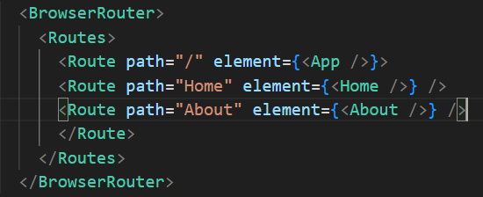
30.Difference b/w Axios and fetch method ?
Axios | Fetch
1.Need to install 3rd party libraries npm i axios | 1.No need to install any 3rd party libraries
2.No need to convert the data in JSON format | 2.Need to convert the data in JSON format
3.we can able to easily handle the Errors in Axios | 3.it is very difficult to handle the Errors in Fetch

31.what is pure component ?
A.Pure component is used in only Class based component. To stop the Unnecessary Re-rendering
Ex:- I have one parent component inside some child components once parent component state is updated inside child components also Re-render need to avoid that Re-rendering we can go for Pure componen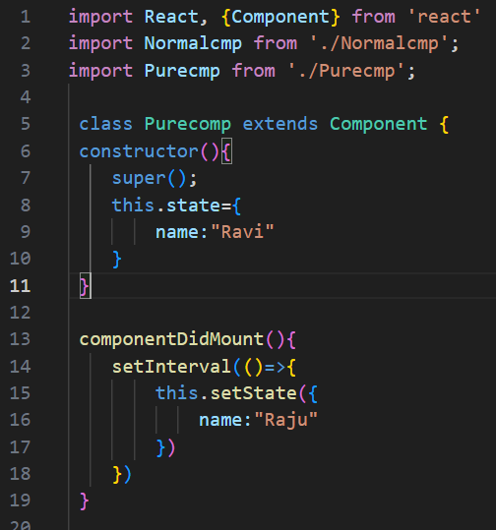
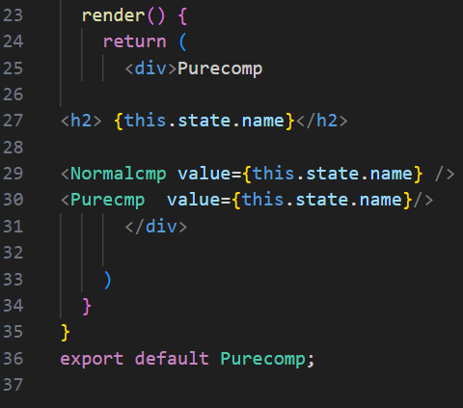
32.what is React.memo?
A. React.memo is used in only Function based component. To stop the Unnecessary Re-rendering
Ex:- I have one parent component inside some child components once parent component state is updated inside child components also Re-render need to avoid that Re-rendering we can go for React.memo
Ex :- export default React.memo (<About/>)

Custom component
component is a special component it take input as a existing component return as a new component
- what is Higher Order Component (HOC)?
- Higher order component is a special component it take input as a existing component return as a new component.
Mailny using the Reusable purpose.

import React from 'react';
const withLogger = (WrappedComponent) => {
class WithLogger extends React.Component {
componentDidMount() {

console.log('Component mounted');
}
componentWillUnmount() {
console.log('Component unmounted');
}

render() {
return <WrappedComponent {...this.props} />;
}
}

return WithLogger;
};
// Usage
class MyComponent extends React.Component {
render() {
return <div>Hello, World!</div>;
}
}
const MyComponentWithLogger = withLogger(MyComponent);
export default MyComponentWithLogger;
- What is Redux and Redux Principles ?
A :- Redux is an architecture it is also called as predictable state container and it is also called as open source javaScript library
=> it is mainly used for the managing the whole application state in unidirectional flow.
=> it maintains global store. Which contains an updated state
Principles :- Predictability of Redux is determined by 3 most important principles
1. Single source of truth.
2. State is Read only.
3. Changes are made with pure functions
Redux:- it is an architecture or predictable state container which is mainly used to manage whole application state in uni-directional flow.
It contains 5 main components :-
1.Action
2.Reducer
3.Store
4.Updated state
5.View components (or) UI Components
1.Action :-
=>Action is a pure JavaScript object or payload of the information
=> using Action.Creators method we will create an action object
=> using store.dispatch (action) method we will dispatch an action object
2.Reducer :-
=>Reducer is a pure javaScript function
=>it will take previous state and dispatched action object as a two arguments
=> Based on the inputs it will update a new state
3.State :-
=>if you want to get updated state from Redux store to our React components.
=> we have to use useSeletor( ) and useDispatch ( ) methods to get updated state from Redux store to view components function
useSeletor => extract the data from redux store
usedispatch => display data in action
=> Store:-
For entire redux application we have to create single store that will work as a global store
=> we have to use React.createStore() method to maintain updated state.
=> store contains provider to make state is available to all the components in application.

View Components:-
=> view components are the Components here we will get or access from redux store to update UI.

Middlewares:
Redux Thunk and Redux saga
Redux thunk is a middleware, if you want to do asynchronous operations and if you want to get 3rd party API’s we have to use Redux thunk.
Redux Saga is a middleware, if you want to do asynchronous operations and if you want to get 3rd party API’s we have to use Redux Saga
Redux saga generators using yield key word upload video play video

Pure Function:
A function is a process which takes some input,called arguments, and produces some output called a return value.
=> a function is called pure if it follows
A function returns same inputs always return some output
No side effects, I.e it does not alter input data.
No maintain of local & global variables.

Custom Hook React
A custom hook in React is a reusable function that encapsulates logic React's hooks (like useState, useEffect) to manage state and side effects across components. Custom hooks enable code reusability, and better readability.
Any api call use create one api fetch component
Same component use multiple components

• Code Reusability:
- Custom hooks allow you to extract reusable logic from components, making your code more modular and DRY (Don’t Repeat Yourself). For example, instead of duplicating the same API-fetching logic across multiple components, you can create a custom hook like useFetch.
• Separation of Concerns:
- Logic and UI are separated. Custom hooks handle the logic, while components focus on rendering the UI.
• Cleaner Code:
- Components become less cluttered because the complex logic is moved to a custom hook.
• Share Logic Between Components:
- They enable the sharing of logic that cannot be achieved with Higher-Order Components (HOCs) or render props. For instance, hooks can encapsulate stateful logic and side effects in a way that's easier to use.
• Improved Readability and Maintainability:
- Custom hooks give meaningful names to the logic they encapsulate, making the codebase easier to understand and maintain.
• Enhanced Testing:
- Logic extracted to custom hooks can be tested independently of components, improving test coverage.
• Avoid Duplication:
- When multiple components share similar logic, a custom hook prevents code duplication, reducing bugs and inconsistencies.

Lazy Loading react
Lazy loading in React.js is a used to improve the performance of web applications by loading certain components, routes, or modules only when they are needed, rather than loading them all at once when the application initially loads. This can significantly reduce the initial load time and resource usage of your application, especially for larger and more complex applications.
React provides a built-in way to implement lazy loading using React.lazy() and Suspense.
React.lazy(): Wrap the import of the module you want to lazy load using
React.lazy().
This function takes a function that calls the import() function,
which returns a Promise that resolves to a module containing the component.
Suspense: Wrap the lazy loaded component with a Suspense component.
This component allows you to specify a fallback UI to display while the lazy component is loading.
import React, { Suspense } from 'react';
// Lazy load the component
const LazyComponent = React.lazy(() => import('./LazyComponent'));
const App = () => {
return (
<div>
{/* Wrap lazy loaded component with Suspense */}
<Suspense fallback={<div>Loading...</div>}>
<LazyComponent />
</Suspense>
</div>
);
};
export default App;
We use React.lazy() to lazy load the LazyComponent.
The import is wrapped in a function to ensure it's only loaded when needed.
We use the Suspense component to specify a fallback UI
(in this case, a simple "Loading..." message) that will be displayed while the
LazyComponent is loading.
Improve performance in react Application
React.fragment => avoid extra nodes
<div> </div> instead of div write <React.fragment> not accupy the line of space not occupy any memory
React.Memo => stop unnecessery re rendarings
Pure component=> stop unnecessery re rendarings class componet
Hoc reusable code no need to write agai again same code
Lazyloading => for reduce the initial loading time.
useMemo => memorized value
useCallback => memorized function
key props : unique identify
minified css in js

HOC
HOC means higher order component input as a existing component and it will return as a new component
We are create one button use multiple times you can use.
Ex. Alert , Model
Reusable purpose we can use hoc

Hoc class base component

Portals
- Portal is an advanced concept in react which provides a way to render child component outside of parent DOM hierarchy.
- If any child component having modal/popup/tooltip in its JSX then its parent component's css will effect the child,s css.
- To implement a portal in React, you use the ReactDOM.createPortal() method. This method allows you to specify the content you want to render and the target DOM element where it should be inserted.
- Create one more div in index.html file to render child component in which modal develops.
<div id='model-root'></div>
- In child component JSX use the below to create portal.
=> ReactDOM.createPortal(modal, document.getElementById(model-root))
- By using portals, you can achieve more flexibility in rendering elements and create better user experiences when it comes to managing overlapping or out-of-flow components in React applications.

Error Boundary
Error Boundaries are React components that catch JavaScript errors anywhere in their child component tree, log them, and display a fallback UI instead of crashing the entire application.
They catch errors in rendering, lifecycle methods, and constructors of child components.
class components can be Error Boundaries (componentDidCatch).
getDerivedStateFromError

In functional Components install library react-error-boundary
<ErrorBoundary FallbackComponent={FallbackUI}> <ChildComponent />
</ErrorBoundary>

SSR (Server-Side Rendering): The server generates the full HTML page on request, improving SEO and first load time but increasing server load.
CSR (Client-Side Rendering): The browser loads a minimal HTML shell and JavaScript takes over to render content dynamically, improving interactivity but causing a slower first paint.

Redux RTK(Redux tool kit)
Using the Redux Toolkit (RTK) write Redux logic, providing simplified state management with built-in utilities for reducers, actions, and middleware. It enhances Redux by reducing boilerplate, improving performance, and offering features like CreateSilce CreateAsyncThunk and RTK Query
Key Features of Redux Toolkit:
- configureStore - Simplifies store setup with built-in middleware like Redux Thunk.
- createSlice - Combines reducers and actions in a single function, reducing boilerplate.
- createAsyncThunk - Handles async actions like API calls without manually dispatching actions.
- createEntityAdapter - Helps manage normalized state for collections of data.
- Built-in Middleware - Comes with Redux Thunk for handling async logic.
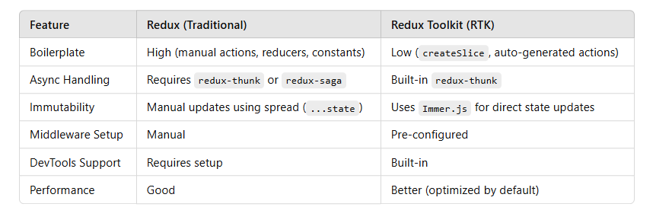

New Features in React 18

Concurrent Rendering (Automatic)
- Enables rendering multiple UI updates simultaneously without blocking the main thread.
- Improves app responsiveness, especially for slow network conditions or complex UI updates.

Suspense for Data Fetching
- Enhances lazy loading and asynchronous operations.
- Works natively with frameworks like Next.js for server-side rendering (SSR).

3️⃣ Transition API (useTransition, startTransition)
- Differentiates between urgent and non-urgent updates.
- Prevents UI blocking by keeping urgent updates (like input typing) responsive while deferring other updates.

New useId() Hook
- Generates stable, unique IDs for components.
- Useful for accessibility attributes and form labels.

Automatic Batching
- Combines multiple state updates into a single re-render, even for async functions.
- Previously, only event handlers had batching.

New useDeferredValue() Hook
- Creates a delayed version of a state value to prevent UI lag.
- Useful for search results, filtering, or expensive computations.
const deferredValue = useDeferredValue(searchInput);

New useSyncExternalStore() Hook
- Standard way to subscribe to external stores like Redux.
- Ensures consistent updates in concurrent mode.

Git
Git multiple commit to single commit
git rebase -i origin/main

axios.interceptors
before a request is sent or before a response is handled.
- Request interceptors → Modify requests (e.g., add auth tokens, log requests).
- Response interceptors → Handle or transform responses (e.g., refresh token, global error handling).
- They act like middleware — every request/response passes through them.
- Useful for avoiding repetitive code across multiple API calls.

Key Prop
The Key prop attribute used to elements in a list to help React identify which items have changed, been added, or removed

React 19 Features

Core Features
- Actions API
Simplifies handling form submissions and state updates using async functions, integrating seamlessly with React's concurrent rendering.
- Server Components
Allows components to be rendered on the server, reducing client-side JavaScript and enhancing performance.
- React Compiler
Optimizes React code behind the scenes, eliminating the need for useMemo and useCallback in many cases.
- New use() Hook
Enables fetching data directly within components, simplifying asynchronous operations.
- useOptimistic Hook
Provides a way to optimistically update the UI while awaiting server responses useFormState & useFormStatus Hooks
Enhance form handling by managing form state and submission status more effectively.

Performance & Rendering
- Concurrent Rendering Enhancements
Improves UI responsiveness by allowing React to work on multiple tasks simultaneously.
- Streaming Suspense
Facilitates real-time data fetching, making the UI more interactive and responsive.
- Automatic Batching
Combines multiple state updates into a single render, reducing unnecessary re-renders.

forwardRef
forwardRef lets parent components access a child’s DOM node or React element.
Useful for building reusable input components, modal controls, or custom UI libraries.

